1) Because of budget issues, the HR department needs a report that displays the last

name and salary of employees who earn more than $12,000. Save your SQL

statement as a file named lab_02_01.sql . Run your query.

SELECT last_name, salary

FROM employees

WHERE salary > 12000;

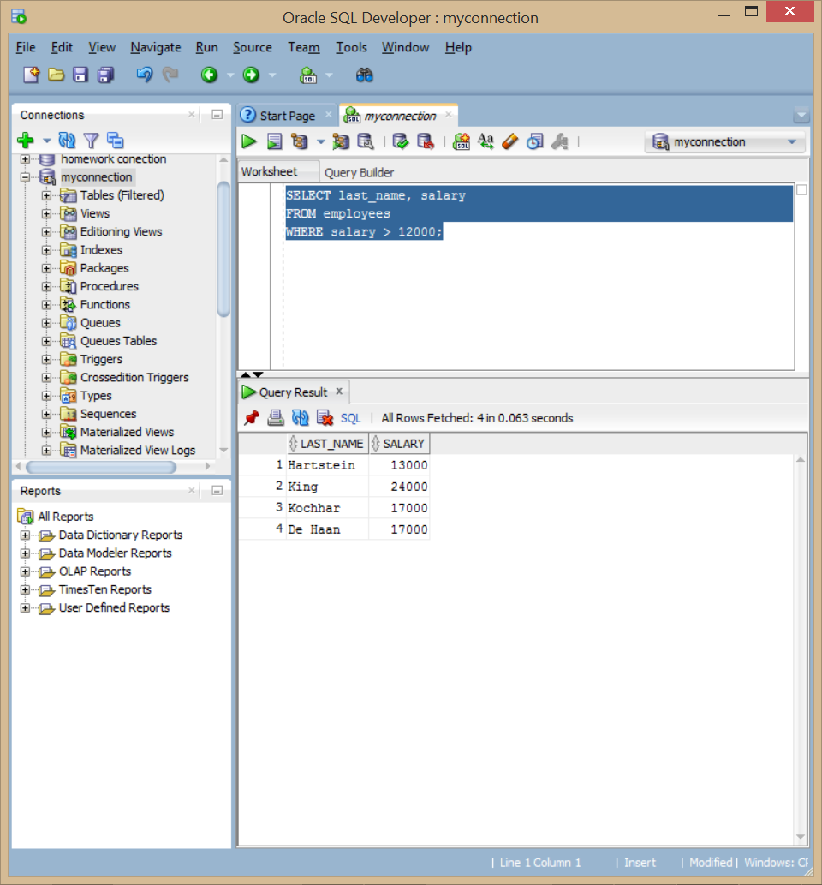

2) Open a new SQL Worksheet. Create a report that displays the last name and

department number for employee number 176. Run the query.

SELECT last_name, DEPARTMENT_ID

FROM employees

WHERE EMPLOYEE_ID = 176;

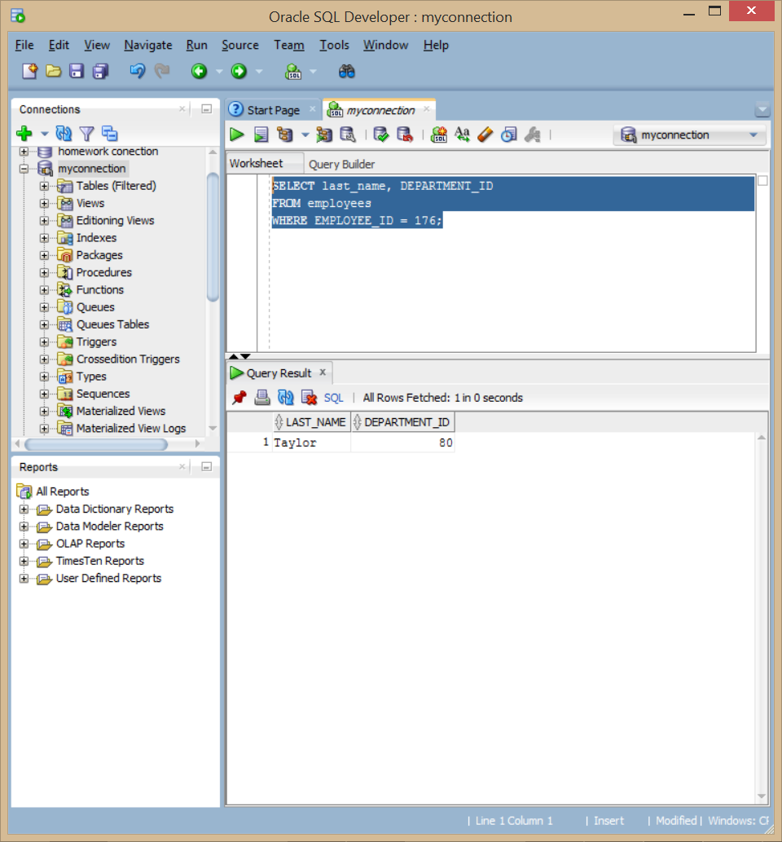

3) The HR department needs to find high-salary and low-salary employees. Modify

lab_02_01.sql to display the last name and salary for any employee whose salary is not

in the range of $5,000 to $12,000. Save your SQL statement as lab_02_03.sql .

SELECT last_name, salary

FROM employees

WHERE salary > 12000 or salary < 5000;

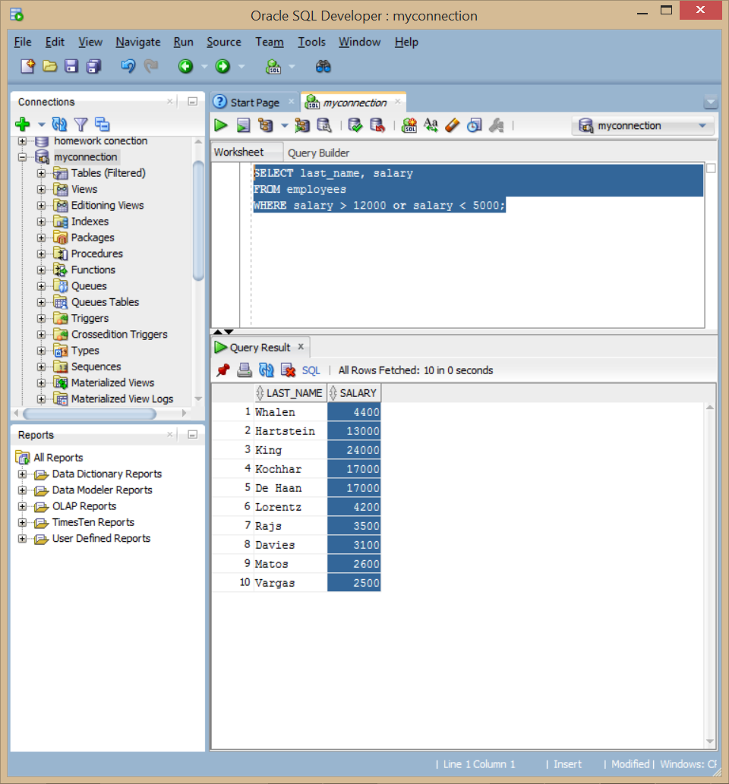

4) Create a report to display the last name, job ID, and hire date for employees with the

last names of Matos and Taylor. Order the query in ascending order by the hire date.

SELECT LAST_NAME, JOB_ID, HIRE_DATE

FROM employees

WHERE LAST_NAME IN ('Matos', 'Taylor')

Order by HIRE_DATE;

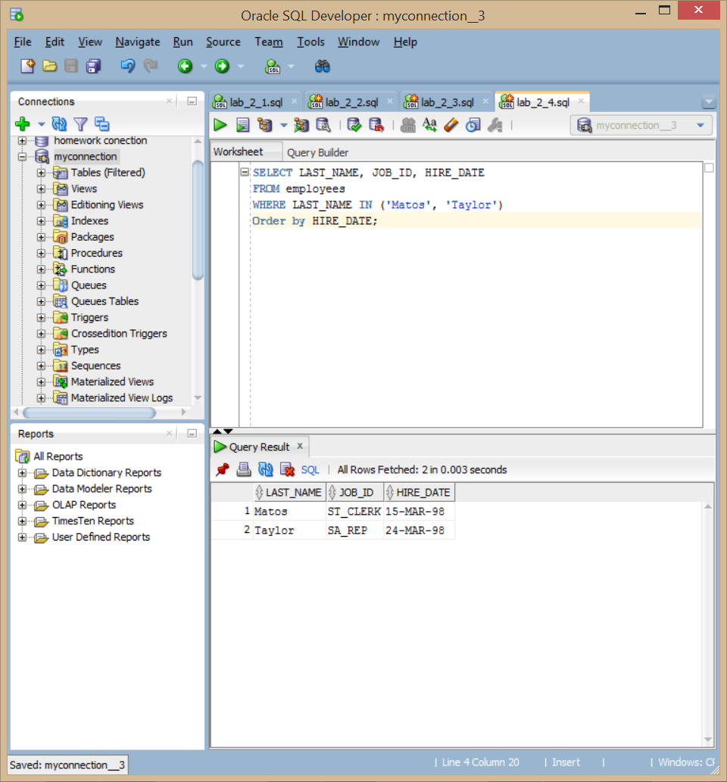

5) Display the last name and department ID of all employees in departments 20 or 50 in

ascending alphabetical order by name.

SELECT LAST_NAME, DEPARTMENT_ID

FROM employees

WHERE DEPARTMENT_ID in (20, 50)

Order by last_name ASC;

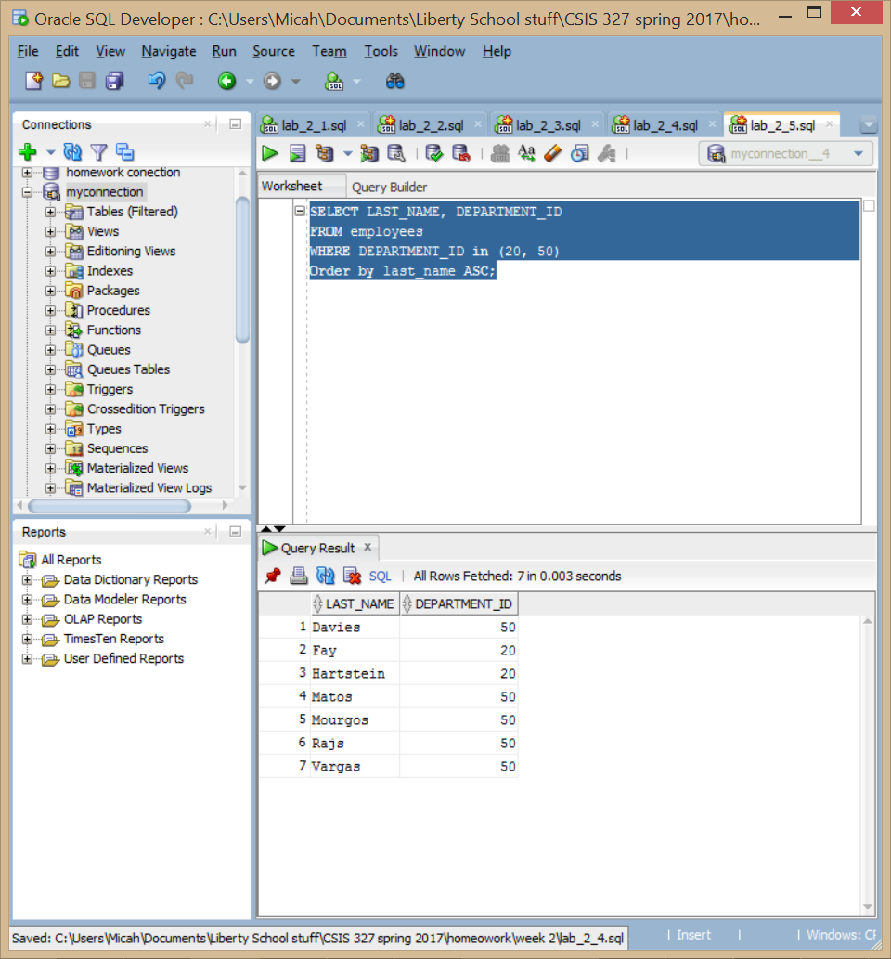

6) Modify lab_02_03.sql to display the last name and salary of employees who earn

between $5,000 and $12,000, and are in department 20 or 50. Label the columns

Employee and Monthly Salary , respectively. Save lab_02_03.sql as lab_02_06.sql again.

Run the statement in lab_02_06.sql .

SELECT last_name "Employee", salary "Monthly Salary"

FROM employees

WHERE salary < 12000 and salary > 5000

and department_id in (20,50);

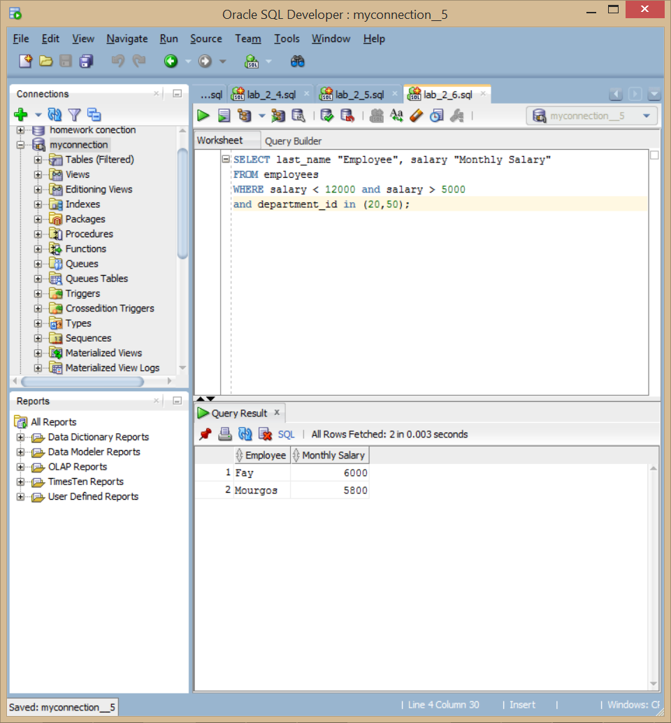

7) The HR department needs a report that displays the last name and hire date for all

employees who were hired in 1994.

select last_name, hire_date

from EMPLOYEES

where HIRE_DATE LIKE '%94';

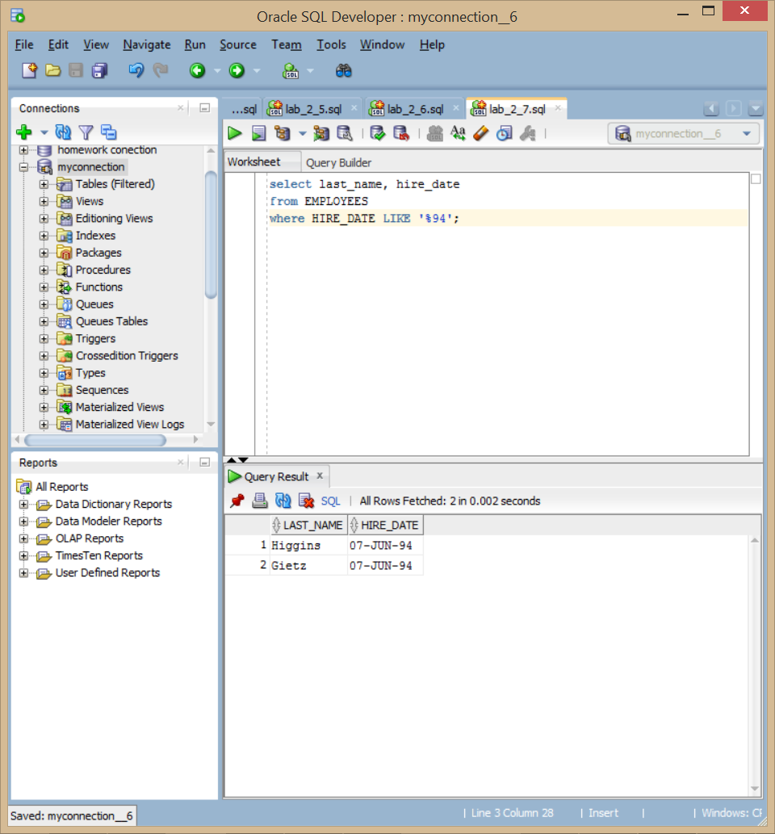

8) Create a report to display the last name and job title of all employees who do not

have a manager.

select LAST_NAME, JOB_ID

from EMPLOYEES

where MANAGER_ID is null;

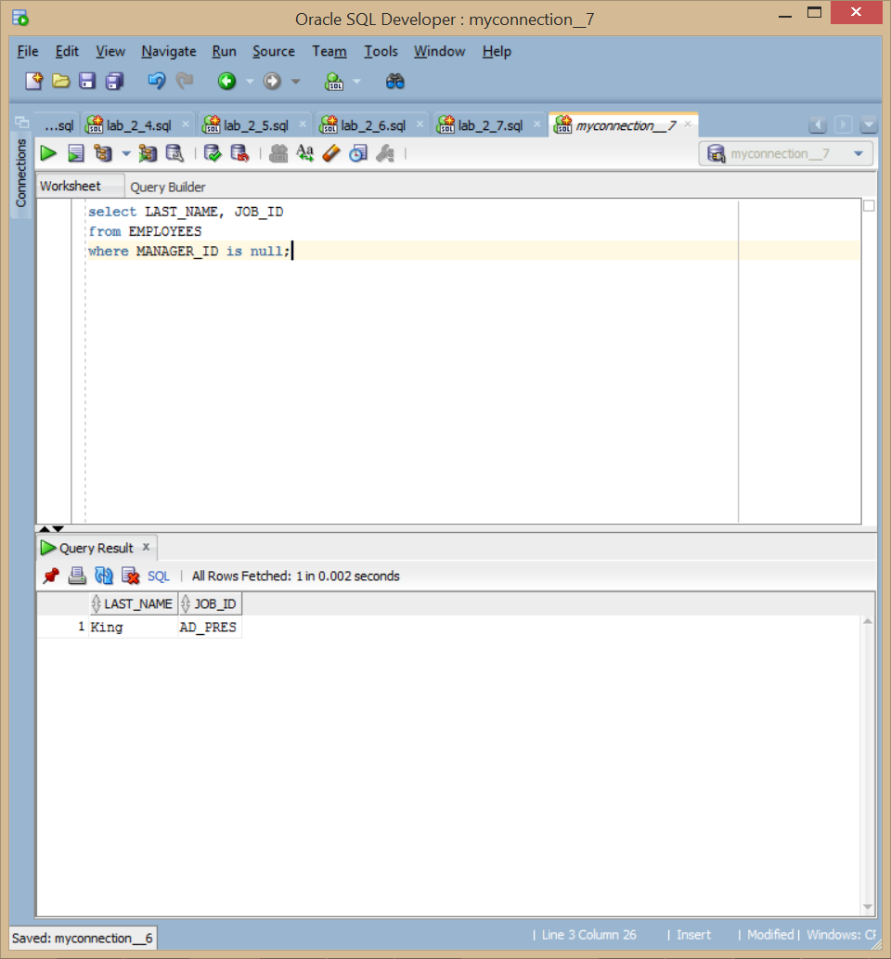

9) Create a report to display the last name, salary, and commission of all employees who

earn commissions. Sort data in descending order of salary and commissions.

Use the column’s numeric position in the ORDER BY clause.

select LAST_NAME, SALARY, COMMISSION_PCT

from EMPLOYEES

where COMMISSION_PCT is not null

order by SALARY desc, COMMISSION_PCT desc;

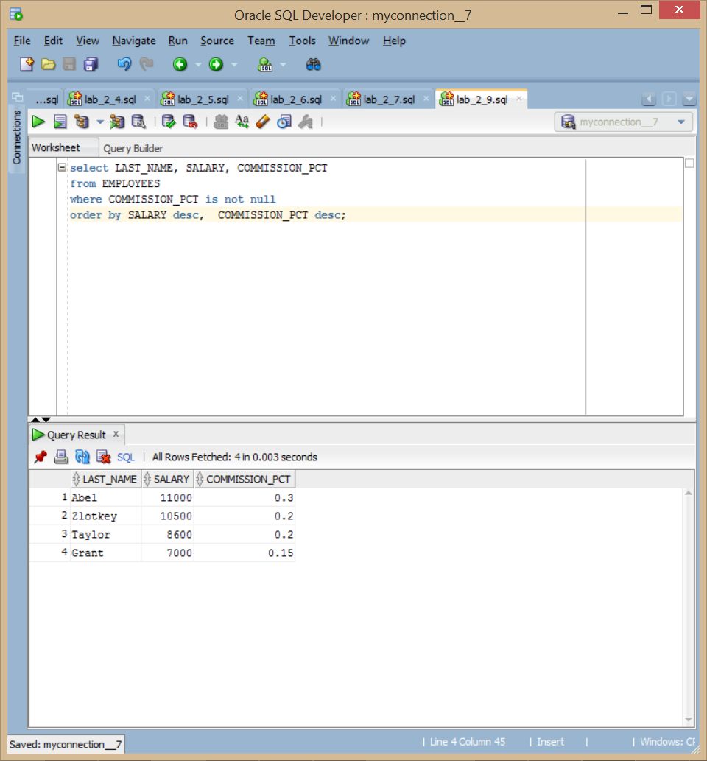

10) Members of the HR department want to have more flexibility with the queries that

you are writing. They would like a report that displays the last name and salary of

employees who earn more than an amount that the user specifies after a prompt. Save

this query to a file named lab_02_10.sql . If you enter 12000 when prompted, the report

displays the following results:

SELECT last_name, salary

FROM employees

WHERE salary > &amount ;

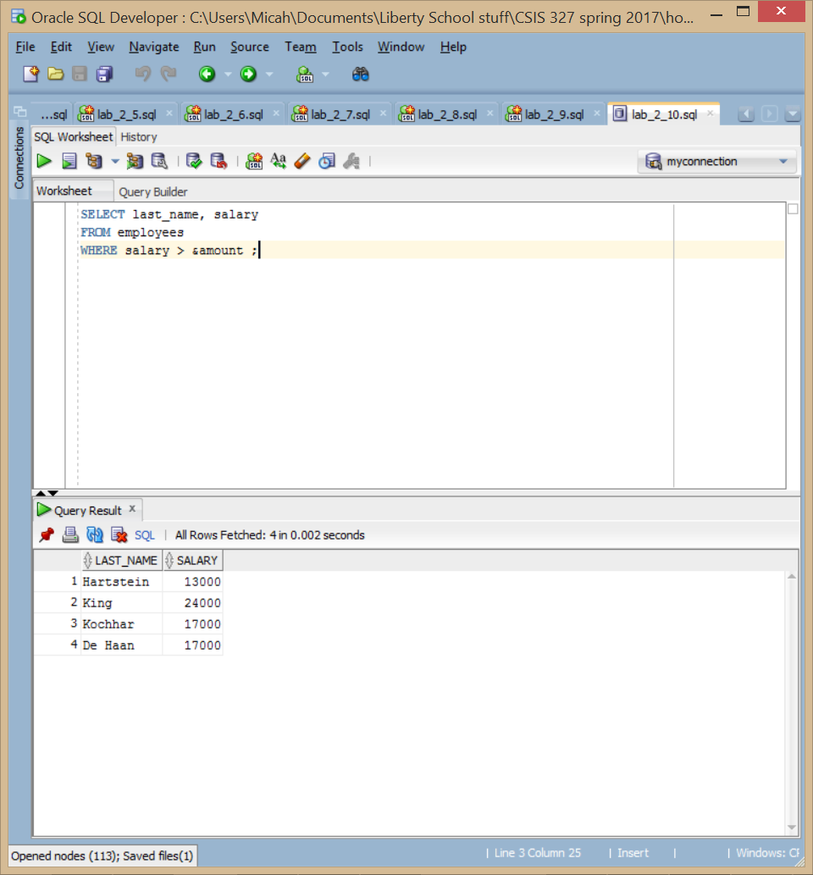

11) The HR department wants to run reports based on a manager. Create a query that

prompts the user for a manager ID and generates the employee ID, last name, salary,

and department for that manager’s employees. The HR department wants the ability

to sort the report on a selected column. You can test the data with the following

values: manager_id = 103, sorted by last_name:

manager_id = 201, sorted by salary:

manager_id = 124, sorted by employee_id:

SELECT EMPLOYEE_ID, LAST_NAME, SALARY, DEPARTMENT_ID

FROM employees

WHERE MANAGER_ID = &Manger_ID

order by &order_collum;

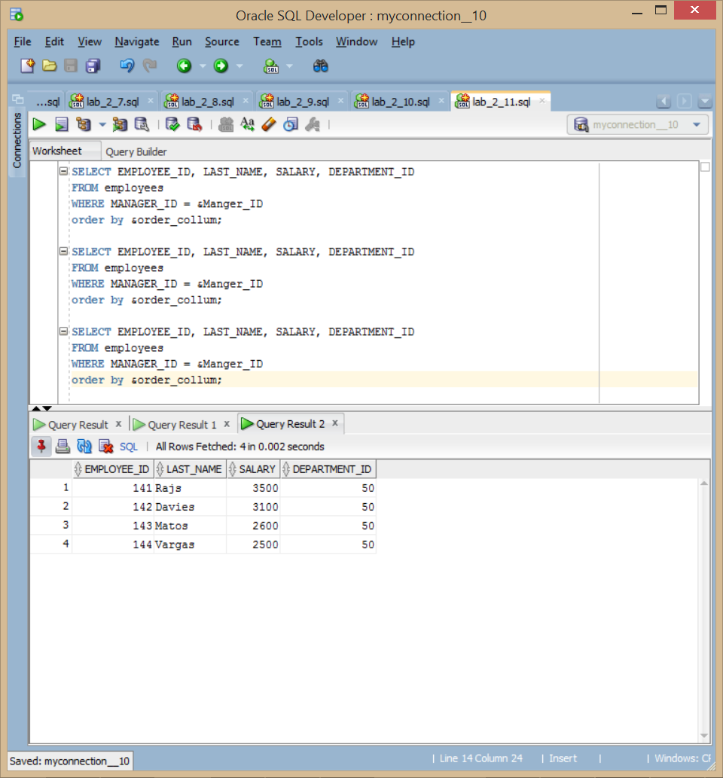

12) Display all employee last names in which the third letter of the name is “a.”

select last_name

FROM employees

where LAST_NAME like '__a%';

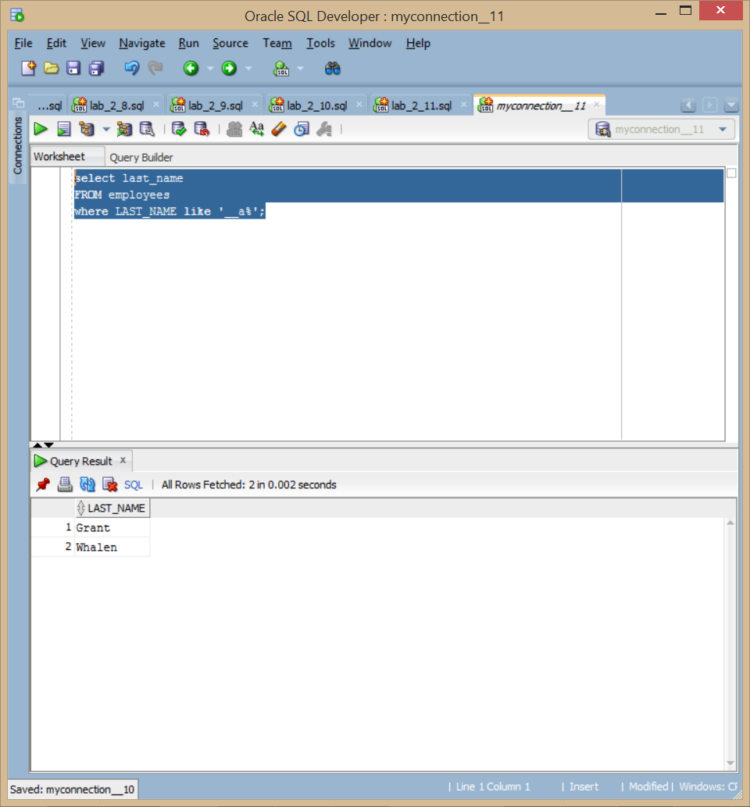

13) Display the last names of all employees who have both an “a” and an “e” in their last

name.

select last_name

FROM employees

where LAST_NAME like '%a%' and LAST_NAME like '%e%';

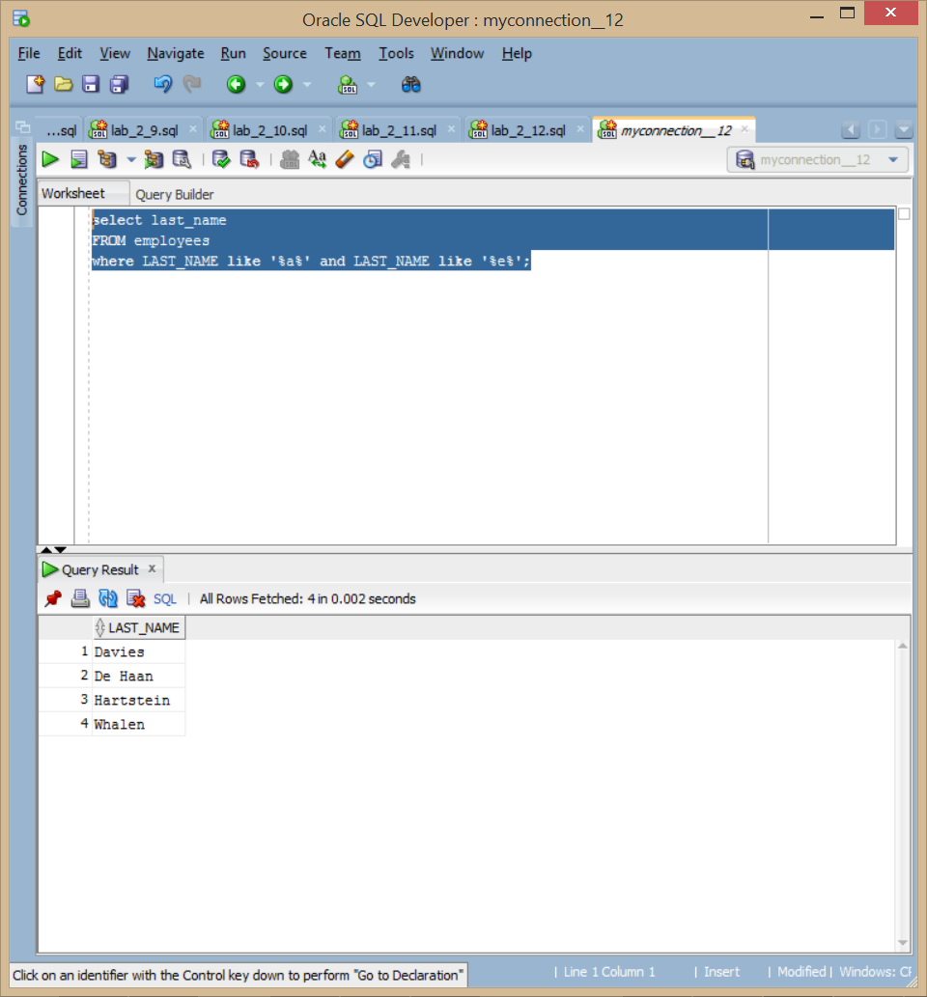

14) Display the last name, job, and salary for all employees whose jobs are either those of

a sales representative or of a stock clerk, and whose salaries are not equal to $2,500,

$3,500, or $7,000.

select last_name, job_id, salary

From EMPLOYEES

where JOB_ID in ('SA_REP', 'ST_CLERK')

and SALARY not in (2500,3500,7000);

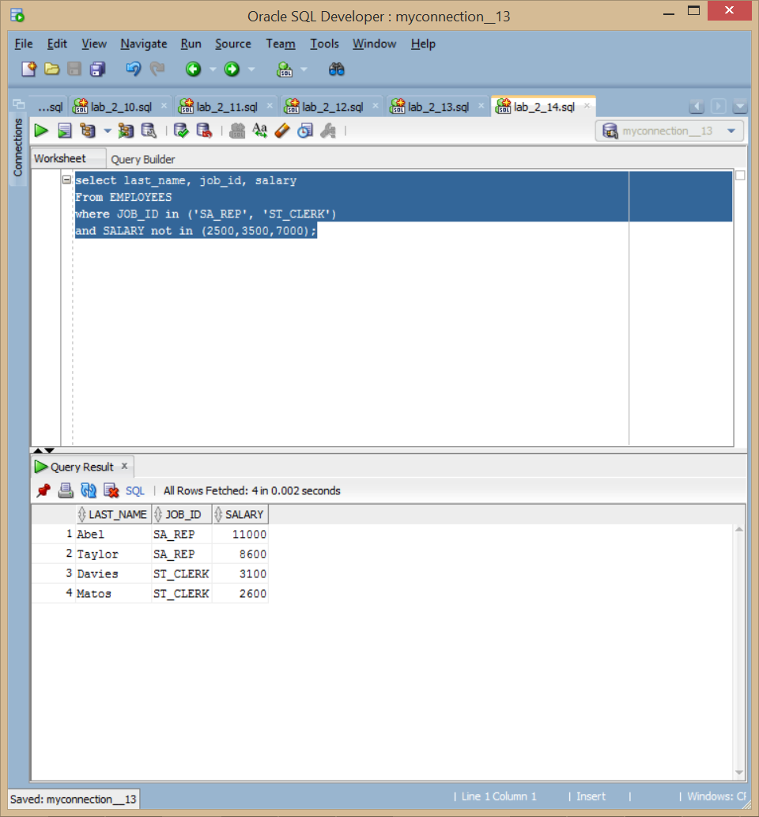

15) Modify lab_02_06.sql to display the last name, salary, and commission for all

employees whose commission is 20%. Save lab_02_06.sql as lab_02_15.sql again.

Rerun the statement in lab_02_15.sql

SELECT last_name "Employee", salary "Monthly Salary", COMMISSION_PCT "Commission"

FROM employees

WHERE COMMISSION_PCT = .2;

